West Bohemian Museum in Plzeň, contributory organization
Kopeckého sady 2, 301 00 Plzeň, Czech Republic

Consent to the processing of personal data
I.
Identification and the purpose of the processing
I
Name and Surname
e-mail
_________________________________________
_________________________________________
delivery address + state: ________________________________________
give my consent to have my personal data (name and surname, e-mail, delivery
adress) processed by
West Bohemian Museum in Plzeň, contributory organization
IČO: 00228745
based in Kopeckého sady 2, 301 00 Plzeň, Czech Republic
subsidiary Dr. Bohuslav Horak Museum in Rokycany
adress: J. Urbana square 141/I, 33701 Rokycany, Czech Republic
as the Controller (henceforth known as „Controller“),
in order to conform to the REGULATION (EU) 2016/679 OF THE EUROPEAN
PARLIAMENT AND OF THE COUNCIL of 27 April 2016 on the protection of natural
persons with regard to the processing of personal data and on the free movement of
such data, and repealing Directive 95/46/EC (General Data Protection Regulation)
These personal data will be processed by the Controller for the purpose:
13. ROKYCANY BIENNIAL EXHIBITION OF GRAPHIC ARTS – registering
and processing of personal data from the incoming application form and for the awards
ceremony. The author agrees with the publication of his/her name and surname, the
country of provenience and of photographs showing works in the exhibition catalogue.
II.
1
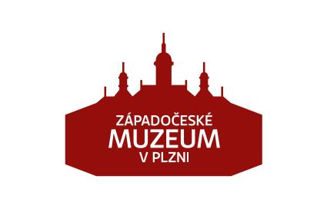

I give my consent to the above mentioned processing. The consent is freely given and
I am aware, that the consent can be taken back anytime. I was properly informed, that
the withdrawal of my consent must be done in a verifiable form, at best in written form.
III.
Instruction
I am aware, that according to the General Data Protection Regulation I have the right:
•
•
to take back my Consent anytime,
to request information about which of my personal data are being processing by
the Controller,
•
•
to request explanation about the processing of personal data,
to request the Controller to give access to my personal data and allow me to
update or rectify these data,
•
to request the Controller to erase personal data.
In _______________ date _______________
Signature ________________
.
2

